CITY OF SEATTLE
ORDINANCE __________________
COUNCIL BILL 118834
..title
AN ORDINANCE relating to public outreach and engagement; creating a Community Involvement Commission to advise and make recommendations to the Mayor and City Council; amending Sections 3.35.010, 3.35.030, and 3.35.050 of the Seattle Municipal Code; and adding a new Chapter 3.62, consisting of Sections 3.62.010, 3.62.020, 3.62.030, 3.62.040, 3.62.050, and 3.62.060, to the Seattle Municipal Code.
..body
WHEREAS, the mission of the Department of Neighborhoods is empower people to make positive contributions in their communities and neighborhoods, build inclusive partnerships across the City, and bring government close to all people in a way that ensures equitable access to government resources;
WHEREAS, a focus on equity is essential to any community involvement process in order to build relationships and improve outcomes, especially for under-represented and under-served communities, including, but not limited to, renters, immigrants and refugees, communities of color, people experiencing homelessness, LGBTQ persons, low-income households, youth, and seniors; and
WHEREAS, Resolution 27709, adopted in 1987, Resolution 28115, adopted in 1989, and Resolution 28948, adopted in 1994, established a process for dividing Seattle into 13 neighborhood District Council districts, each with a District Council comprised of community councils, neighborhood business organizations, and other organizations that wish to participate. Each district council also sends a representative to the citywide City Neighborhood Council; and
WHEREAS, pursuant to Resolution 27709, Resolution 28115, and Resolution 28948, District Councils and the City Neighborhood Council receive dedicated staff support from the Department of Neighborhoods, hold regular public meetings that are to “provide a forum for consideration of common concerns including physical planning, budget allocations and service delivery and for the sharing or ideas for solutions to common problems,” and provide input to the Mayor and City Council regarding eligible applications for Neighborhood Matching Fund allocations; and
WHEREAS, as the composition of Seattle’s population continues to change, the City needs to continually revisit, revise, and expand its public engagement efforts in order to ensure representatives from all demographic groups have opportunities to participate in City decision-making processes that respond to their unique preferences and needs, and that barriers that discourage people from participating are eliminated; and
WHEREAS, the public involvement programs and practices advanced by City departments should reflect Seattle’s commitment to the Race and Social Justice Initiative, which focuses on ending structural racism and race-based inequities both within City government and across the community; and
WHEREAS, as part of the City’s 2016 Adopted Budget, the City Council requested that the Department of Neighborhoods develop a plan to provide more equitable community engagement, with a particular focus on Department of Neighborhoods staff resources assigned to support the District Council system; and
WHEREAS, on July 13, 2016, Mayor Murray issued Executive Order 2016-06 directing the Department of Neighborhoods to prepare an ordinance that (1) creates a Seattle Community Involvement Commission, and (2) supports the implementation of more equitable public involvement techniques by amending Chapter 3.35 of the Seattle Municipal Code to afford Department of Neighborhoods staff the capacity to assist and engage the full range of community voices; NOW, THEREFORE,
BE IT ORDAINED BY THE CITY OF SEATTLE AS FOLLOWS:
Section 1. Section 3.35.010 of the Seattle Municipal Code, last amended by Ordinance 124650, is amended as follows:
3.35.010 Department established—purpose
There is established a Department of Neighborhoods to provide ((citizens and neighborhoods)) community members and groups with ((consolidated)) coordinated, accessible, and effective tools and resources to:
A. ((To identify)) Identify and address their diverse character and needs;
B. ((To assist their participation in the processes of)) Participate in City government processes;
C. ((To improve)) Improve two-way communications with ((between them and)) City departments;
D. ((To give them the capacity to build)) Build capacity and strengthen their communities;
E. ((To encourage their participation in finding solutions to their problems)) Resolve and respond to issues and challenges facing their communities;
F. ((To encourage their communication and collaboration with other neighborhoods, business)) Communicate and collaborate with other local organizations and community groups; and
G. ((To implement the Neighborhood Planning and Assistance Program adopted by Resolution 27709; and
H. To foster)) Foster understanding, coordination and unity of purpose among ((neighborhoods)) local communities and City government.
H. Promote ongoing engagement and dialogue between and among diverse community groups, toward mutual understanding, respect, and cooperation.
Section 2. Section 3.35.030 of the Seattle Municipal Code, last amended by Ordinance 124650, is amended as follows:
3.35.030 Director—functions
The Director of the Department of Neighborhoods shall manage the department and shall:
A. Serve as liaison with ((citizens, neighborhoods)) residents, neighborhood groups, and other community organizations;
B. Manage the City’s system of neighborhood service centers; ((Manage the City’s system of neighborhood service centers; provide)) provide staff for the Community Involvement Commission, City Neighborhood Council and district councils; ((City Neighborhood Council and district councils and administer))
C. Administer the Neighborhood Matching Fund Program and the Neighborhood Matching Fund;
((C)) D. Conduct outreach programs to elicit ((citizen)) public participation; present ((neighborhood)) community concerns to City departments ((and strengthen departmental responses to neighborhood problems)) ; and strengthen and support the provision of ((assure)) coordinated departmental responses to ((neighborhood)) community concerns, including the delivery of high-quality customer service; and mediate disputes between City departments and affected communities;((and mediate disputes between City departments and affected communities;))
((D)) E. Assist communities in understanding and responding to proposed projects and activities ((affecting local land uses and the quality of the neighborhood environment;)) and ((facilitate community))enable or convene public meetings on issues, including possible City actions having an impact on ((neighborhoods)) communities;
((E)) F. Assist communities in identifying ((problems)) local challenges and needs and help them ((develop, coordinate and)) implement neighborhood and community plans and other actions to address such issues; ((and report annually to the City Council regarding the status of neighborhood plans;))
G. Support neighborhood-based community building through technical assistance, translation services, capacity building, and other resources, as appropriate. Promote intergenerational and multilingual neighborhood-based organizing, including engagement of racially and economically diverse communities.
H. Provide technical assistance, training, and access to engagement tools, including digital methods, to ((neighborhoods)) communities undertaking general organizing efforts; and
((G. Oversee and direct the Neighborhood Action Team Seattle to foster a multi-department and community engagement approach to solving complex public safety problems;))
I.H. Perform such other duties as assigned by the City in its annual budgets or by ordinance from time to time.
Section 3. Section 3.35.050 of the Seattle Municipal Code, last amended by Ordinance 117977, is amended as follows:
3.35.050 Neighborhood Matching Subfund ((.))
A. There is hereby established in the City Treasury, as a subfund of the General Fund, a Neighborhood Matching Subfund to be administered by the Director of the Department of Neighborhoods and into which shall be deposited whatever sums the City may receive or allocate from time to time or during the annual budget process ((for neighborhood planning and assistance purposes)) .
B. Disbursements from the Neighborhood Matching Subfund shall comply with all applicable provisions of the State Constitution, State law, City Charter, and ordinances of the City, and shall be made from appropriations authorized by the City Council by ordinance.
C. Funds appropriated from the Neighborhood Matching Subfund shall not lapse and shall be carried over each year until fully expended, reallocated by administrative action, or abandoned or reappropriated to other authorized activities.
D. There is hereby established in the Neighborhood Matching Subfund a new account called the Neighborhood Participation Account into which shall be deposited any cash proceeds provided as matching participation in furtherance of projects authorized by the City Council as part of the Neighborhood Matching Subfund program.
E. Funds received and deposited in accordance with the provisions of subsection 3.35.050.D ((of this section)) are available for appropriation for uses contemplated by the Neighborhood Matching Subfund Program.
Section 4. A new Section 3.35.055 is added to the Seattle Municipal Code, as follows:
3.35.055 Review of Grant Proposals
1. The City recognizes as City advisory bodies thirteen Neighborhood District Councils, which are composed of representatives of community councils, neighborhood business organizations and other community-based organizations that represent people or businesses with an interest in the neighborhood districts shown on Map 1 of Section 3.35.055.
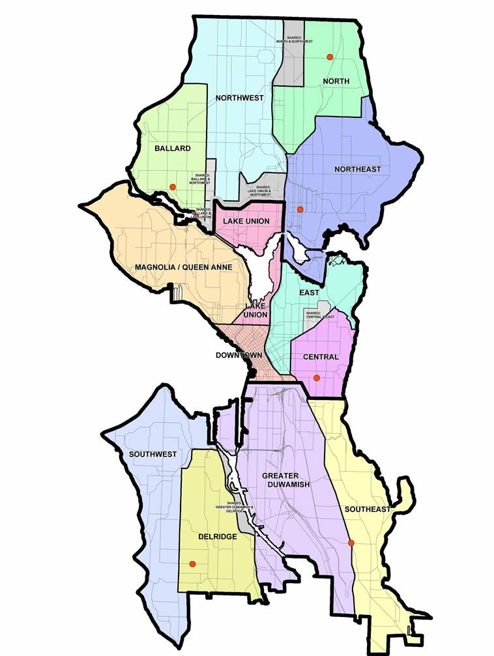
Map 1 for Section 3.05.055
2. Before the Community Involvement Commission reviews community grant proposals, as described in Section 3.62.040 A.2., the Department of Neighborhoods shall consult with Neighborhood District Councils on proposals for Neighborhood Matching Fund grants over $25,000. The Department shall ask existing and active Neighborhood District Councils to rate and rank eligible applications for grants that fall within their district. The Department shall include these ratings and rankings with any recommendations submitted to the Mayor and City Council and shall consider them in making any recommendations for the grants. The Department shall support the Neighborhood District Councils in their review of the grant proposals.
Section 45. A new Chapter 3.62 is added to the Seattle Municipal Code as follows:
CHAPTER 3.62 COMMUNITY INVOLVEMENT COMMISSION
3.62.010 Establishment
There is established a Community Involvement Commission to advise and make recommendations to the Mayor and City Council on the development of plans, policies, regulations, strategies, and community grant funding processes that advance equitable public engagement and civic participation in ((the)) The City of Seattle. An early part of the Commission’s task will be to review the performance of the District Councils and the City Neighborhood Council and make a recommendation as to whether they should continue as official City advisory bodies and if so, in what ways they should be improved. The Commission shall act in an advisory capacity only.
3.62.020 Membership
A. The Commission is comprised of 16 members. Appointments shall be made to ensure that varied community perspectives are represented. At least one position shall be held by a representative from each of the seven City Council districts. If a member cannot be found from a particular district, that seat will remain empty. Appointments shall be made, to the extent possible, so that the Commission membership reflects the current demographics of the City, including consideration of historically underrepresented communities.
B. Members serve without compensation.
3.62.030 Appointment and term
A. All positions are numbered one through 16. Individuals shall be appointed into those numbered positions. Members in positions one through seven shall be appointed by a majority vote of the Council, with each member representing the City Council district that corresponds to their position number. Individuals in positions eight through 14 shall be appointed by the Mayor, subject to confirmation by a majority vote of the Council. Position 14 shall be filled by a young adult pursuant to the Get Engaged Program in Chapter 3.51. Members in positions 15 and 16 shall be selected by the Commission subject to approval by the Mayor and confirmation by a majority vote of the Council. All positions shall be filled as soon as practicable after the Council and Mayor have authorized the creation of the Commission. Staff from the Department of Neighborhoods may provide appointment recommendations to both the Mayor and City Council.
B. For the initial round of appointments, odd numbered positions will serve one-year terms and even numbered positions will serve two-year terms. After the conclusion of the initial terms, all subsequent terms of each position shall be for two years, with the exception of the young adult position appointed pursuant to Chapter 3.51 who shall serve a one-year term. No members shall serve more than two full consecutive terms. Any vacancy in an unexpired term shall be filled in the same manner as the original appointment. A member whose term is ending shall continue on an interim basis as a member with voting rights until such time as a successor for that position has been appointed and confirmed by the City Council.
3.62.040 Duties and functions
A. The duties of the Commission include, but are not limited to, the following:
1. Provide advice on priorities, policies, and strategies related to equitable civic engagement and public participation in City decision-making processes. This includes review of proposals brought forward by the City, as well as ones identified by the Commission or submitted by members of the public
2. Advise the Department of Neighborhoods on the review of community grant processes including input received from the District Councils, and make final recommendations to the Department of Neighborhoods on proposals for Neighborhood Matching Fund grants over $25,000.
3. Meet at least ten times per year.
3.62.050 Ancillary powers
A. The Commission shall have the power to:
1. By a majority vote of the Commission, elect or replace one or more Commission members to serve as Chairperson for a one-year term, and elect or replace one or more members to serve as Vice Chairperson for a one-year term, who shall serve as Chair in the absence of the Chairperson.
2. Organize itself, establish committees or subcommittees, and delegate duties for the performance of its work; and
3. Adopt rules of procedure to accomplish its functions.
B. The Department of Neighborhoods shall provide staff support and meeting facilities for the Commission and maintain its records. The Commission may also receive staff assistance from other City departments.
C. Meetings of the Commission shall be open to the public and the Commission shall operate subject to the Washington Open Public Meetings Act (chapter 42.30 RCW). Meeting notifications, agendas, minutes of proceedings, findings and recommendations, annual reports, and other related material shall be available to the public and posted on the Department of Neighborhoods’ website.
3.62.060 Unexcused absences and removal
Any member may request an excused absence. For City Council appointed positions, the Council may remove any member who is absent from three or more consecutive meetings without cause, or otherwise for cause. For mayoral and Commission appointed positions, the Mayor may remove any member who is absent from three or more consecutive meetings without cause, or otherwise for cause. The Commission may recommend, by a majority vote, that the Mayor or Council remove any member who is absent without excuse from three consecutive Commission meetings.
Section 56. This ordinance shall take effect and be in force 30 days after its approval by the Mayor, but if not approved and returned by the Mayor within ten days after presentation, it shall take effect as provided by Seattle Municipal Code Section 1.04.020.
Passed by the City Council the ________ day of _________________________, 2016, and signed by me in open session in authentication of its passage this _____ day of _________________________, 2016.
____________________________________
President ____________ of the City Council
Approved by me this ________ day of _________________________, 2016.
____________________________________
Edward B. Murray, Mayor
Filed by me this ________ day of _________________________, 2016.
____________________________________
Monica Martinez Simmons, City Clerk
(Seal)

